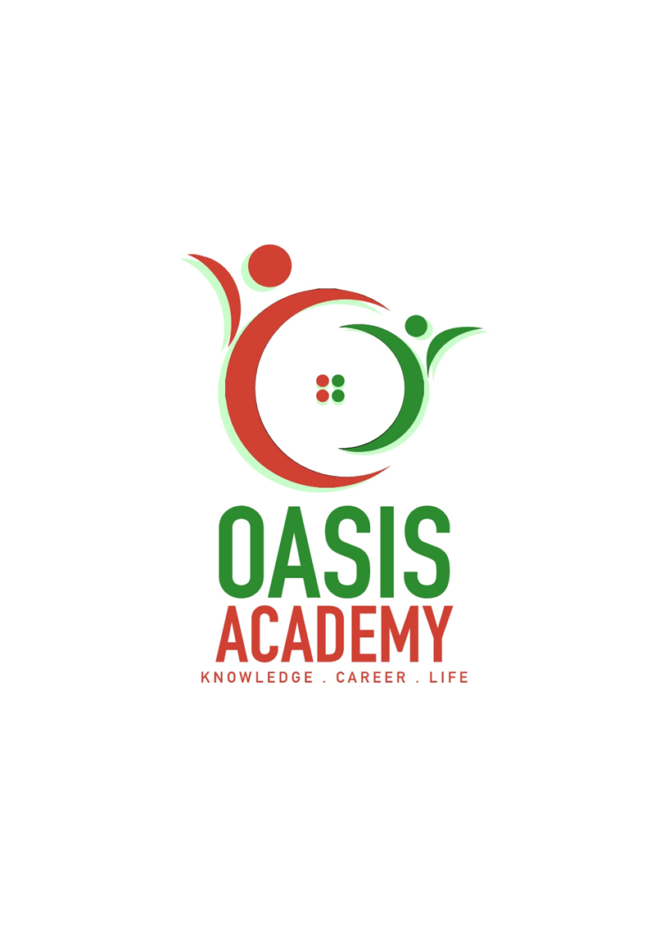

Name: TUNG CHOON KIT

Login ID: tungchoonkit@oasis-portal.com

Course title: Tourism and Hospitality

Subject code: BHM04

Submit date: 11 Sep 2017

**Table of Contents**

|  |  |  |
| --- | --- | --- |
| **No** | **Details** | **Page** |
| 1 | Executive Summary | 2 |
| 2 | Introduction | 3 |
| 3 | Assignment Question |  |
|  | Part 1 | 4-8 |
|  | Part 2 | 9-12 |
|  | Part 3 | 13-15 |
|  | Part 4 | 16-18 |
| 4 | Conclusion | 19 |
| 5 | References | 20-21 |
|  | Appendix |  |

Executive Summary

In the module, I covered the topic about tourism and hospitality. First of fall, I will started my introduction of tourism and hospitality. In the introduction, i will talk about what is tourism and hospitality. In the first question, i will define the tourism and hospitality and explain about hospitality industry. In the second question, i will brief on different type of tourism categories. In the third question, i will describe the lodging accommodation and types of hotel accommodation. In the last questions, I will explain the significant of entertainment in this industry.

Introduction

Hospitality and tourism is about relationship between tourism and hospitality. Tourism is a sector of activity and travelling system. Tourism is describe tourist staying at another place or outside comfort zone no more than a year or less than a year. Important of tourism is can make more income generated for country and consumption of goods and services by tourist.

Hospitality is a relationship between guest and host. Host is like reception front office counter hotel to provide a good services to guest. Hospitality treats the guest goodwill and entertainment of guest visitors or strangers.

Hospitality and tourism is consist of lodging, travel and tourism, recreation, amusements, attraction, resorts and food beverage services. Hospitality and tourism also is a largest employments rate in the country. Tourism also consisting of product like access, accommodation, attraction, activities, amenities, ancillary. Tourism product also called as tourism product 6A. Next, Hospitality industry is a field of service industry. Hospitality industry included lodging, event planning, themes parks, transportation, Cruise line. Hospitality industry have unit like restaurant, hotel, amusement parks. Tourism are categories a few different type of sector in tourism example like leisure tourism, cultural tourism, religion tourism, family tourism, and health tourism.

Lodging accommodation is a sector of hospitality. Lodging accommodation is a luxurious to the moderate hotel and also is a board sector of hospitality like bread and breakfast and facilities. Below are few types of hotel and accommodation services example like hotel, hostel, boutique hotel, resort, eco hotel and capsule hotel.

Entertainment industry is a hospitality industry. Entertainment industry is related the buyers and recipients of all hospitality services. So, this sector of hospitality thrives for us and to Entertainment is a significant part of our travel these days. Tourist during traveling experience lacks fun and entertainment then you might not be able to enjoy your time up to the fullest.

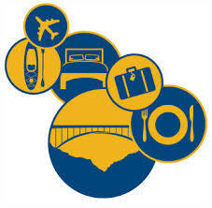 

Question 1

Define the tourism and hospitality

Explain your understanding about hospitality industry.

Tourism is a sector of activity and travelling system. Tourism is describe tourist staying at another place or outside comfort zone no more than a year or less than a year. Important of tourism is can make more income generated for country and consumption of goods and services by tourist.

Hospitality is a relationship between guest and host. Host is like reception front office counter hotel to provide a good services to guest. Hospitality treats the guest goodwill and entertainment of guest visitors or strangers.

Hospitality and tourism is consist of lodging, travel and tourism, recreation, amusements, attraction, resorts and food beverage services. Hospitality and tourism also is a largest employments rate in the country.

Tourism products

The tourism product consist of the 6A’s

Access (transportation)

Access for tourist is very important went tourist travel to another places. Tourist need transportation went they want to go another destination during their travel. Like example now the days people want to travel to go another country need to use air transport to go their destination.

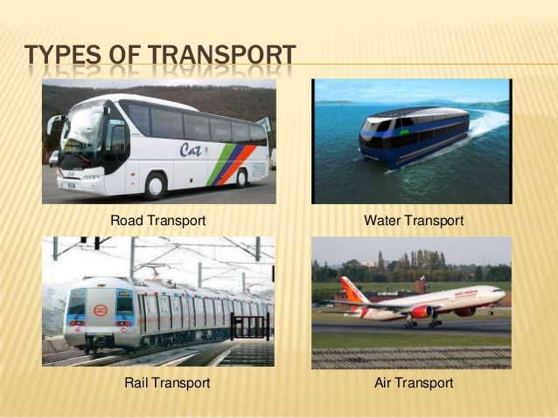

Accommodation

Accommodation in tourism is for tourist to stay at other place more than a week or less than a week. Example like hotel , hostel and resort.

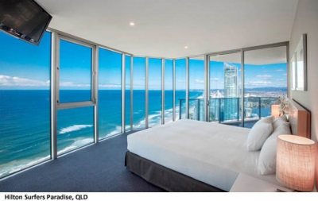

Attraction

Attraction in tourism is tourist will go travel is because some country has a beautiful attraction like Kuala Lumpur KLCC, Singapore Marina Bay Sand and Taiwan Taipei 101.

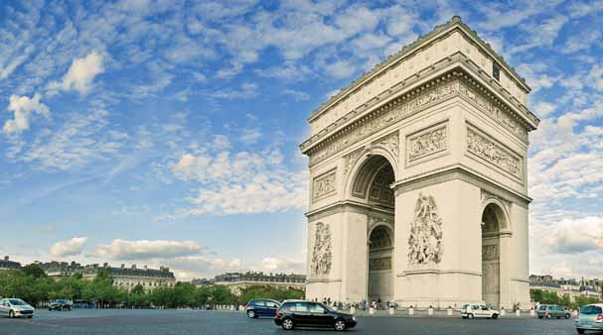

Activities

Some country has their culture activities to attract tourist to travel their country. Europe and the United State people will travel Asia country like Malaysia or Singapore to celebrate their country culture festival like Chinese New Year or National Day celebration.

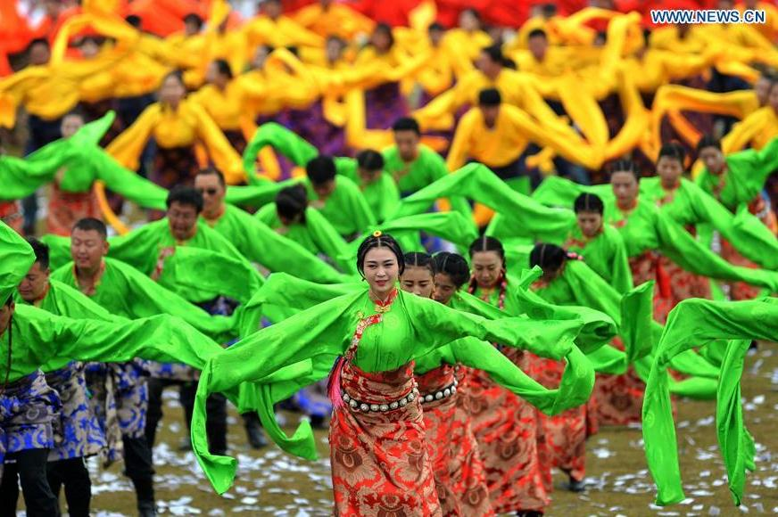

Amenities

Is a useful feature or facility of a building or places. Tourist will enjoy and experience elements of comfort and convenience. Like example hotels have provided swimming pools and hot tubs services.

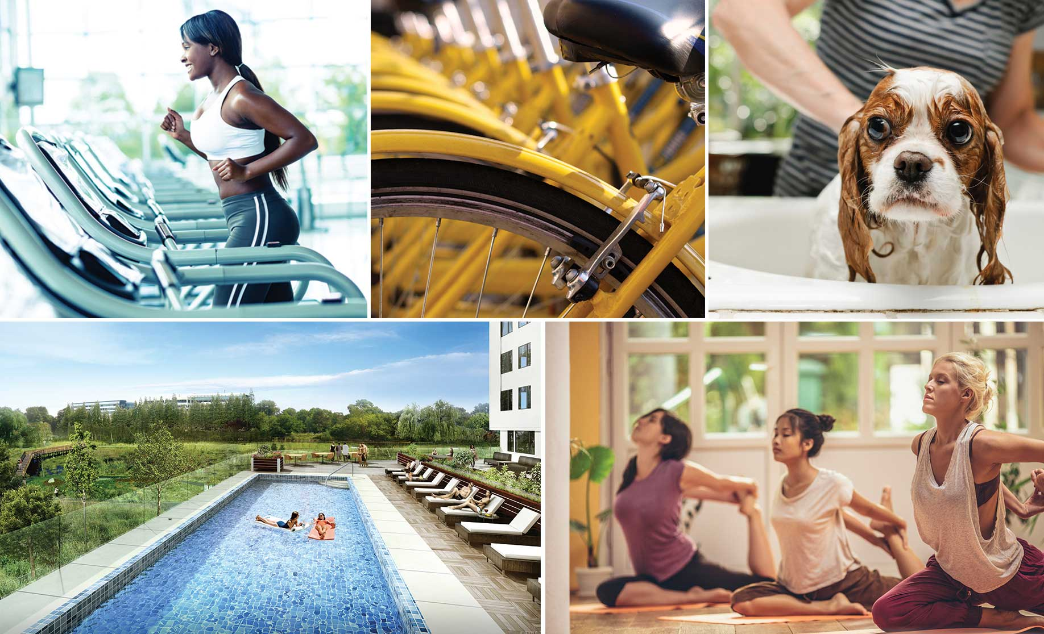

Ancillary

Ancillary is a services in travel and tourism are services that are provided comfort and safe during their travel. Like example, travel insurance which provides insurance for loss of baggage, passport, or any valuables, medical expenses while in a trip.

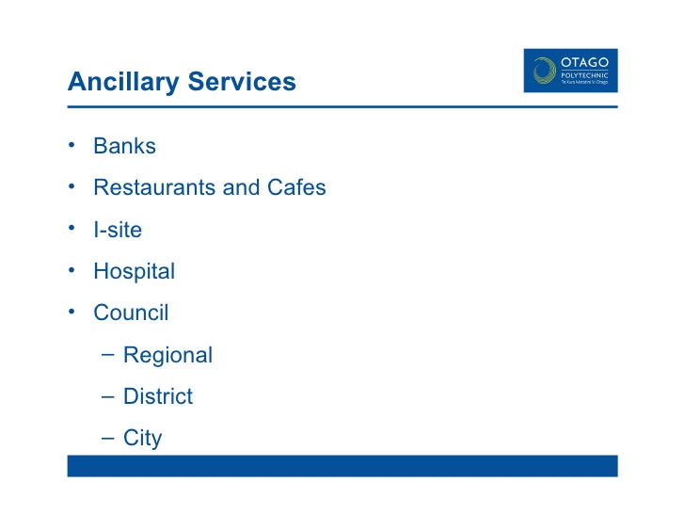

Hospitality industry is a field of service industry. Hospitality industry included lodging, event planning, themes parks, transportation, Cruise line . Hospitality industry have unit like restaurant, hotel, amusement parks.

Hospitality industry has a few different sectors in hospitality industry.

1. Accommodation

Accommodations in hospitality industry is provided living place to tourist during travel to other places. Like example hotels, motels, flotes, and Inns.

Hotels Flotes

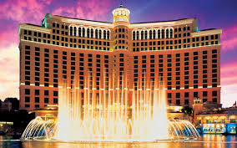 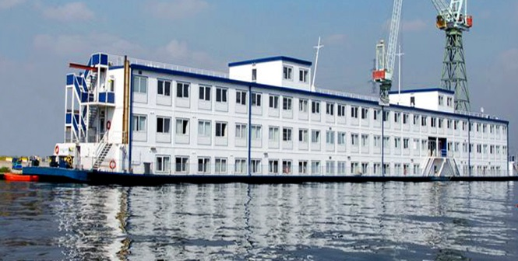

2. Restaurant and bars

Restaurant and bars also is hospitality industry. Tourist will enjoy that country restaurant during travel. Food and beverage is a largest services sector in the worlds. Examples like nights clubs, pubs and restaurant.

Restaurant Bars

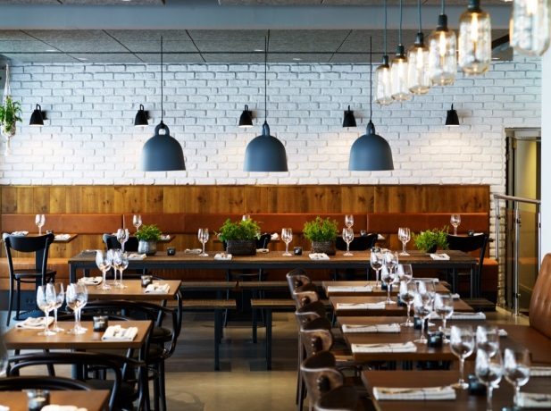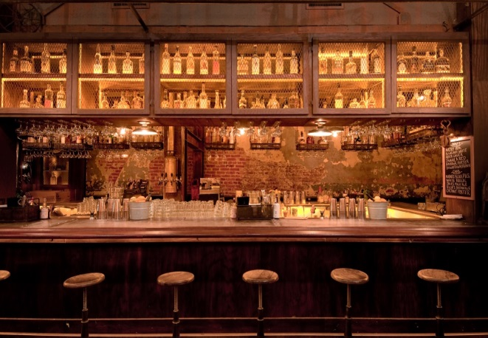

3. Travel and Tourism

Hospitality industry also included travel and tourism. Travel and tourism services are provided tourism information in different country during tourist travel in other places. Like example travel agents and tour operator.

Travel Agents Tour operator

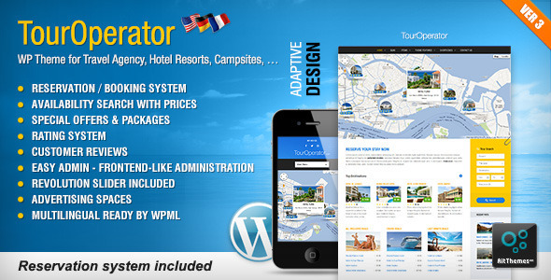

Question 2:

Brief on different type of tourism categories

Define tourism.

Tourism are categories a few different type of sector in tourism.

Leisure tourism

Leisure tourism for tourist is a holiday to experience new culture, new place and new climate from another country.

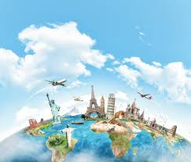

Cultural tourism

Tourist will go to holidays is to learn to practice that county culture and more focus religion from another place. Tourist will more experience other country culture activities.

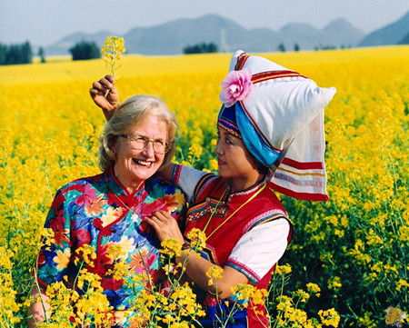

Religions tourism

Religion tourism is also called as Pilgrimage tourism / Spiritual tourism. Tourist will go to travel is because for praying from their culture. The largest of religions takes place the annual Hajj pilgrimage in Mecca, Saudi Arabia.

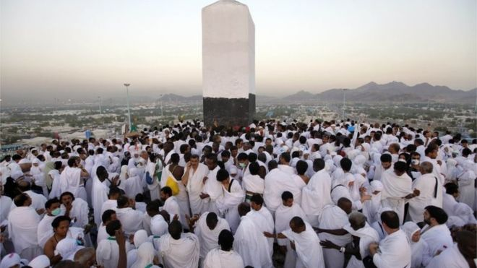

Family tourism

Family tourism involves the family unit and their participation in diverse forms of tourism activity. Some tourist purpose to visit different place is because their family or friends are living different places.



Health tourism

Health tourism also called as medical tourism. Tourist will travelling to go oversea to improve they heath and rebuild their health situation.

Many hospitals have specially designed packages including resorts facilities. Thus health tourism covers one or more of the following aspects-

-Alternative therapy

-change climate



Sports tourism

This tourism refers to travel which involves viewing or participating in a sporting event staying apart from their usual environment. Sports tourism is more focus in sports sector like Olympic and FIFA world cup.

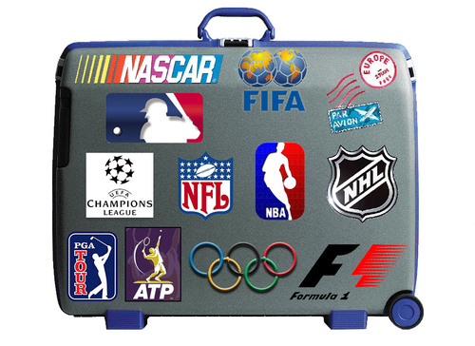

Education tourism

In educational tourism, the main focus of the tour visiting another country to learn about the culture, such as in Student Exchange Programs and Study Tours, organizing specialized lectures of the eminent personalities and for research.

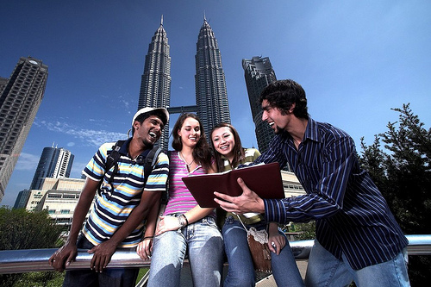

Business tourism

The business traveler’s main motive for travel is work. Business will go travel to expand and observevations business from other country. Business tourism is popularly called as MICE (Meetings, incentives, conferences, and exhibitions) tourism.



Question 3:

Describe the lodging accommodation and type of hotel accommodation.

Lodging accommodation is a sector of hospitality. Lodging accommodation is a luxurious to the moderate hotel and also is a board sector of hospitality like bread and breakfast and facilities. Below are few types of hotel and accommodation services:

1. Hotels

Hotels are provided travelers with paid accommodation and other guest services. Depending on size, location, and amenities hotels will rated one stars until five stars. Hotels also have facility like swimming pools and breakfast services.

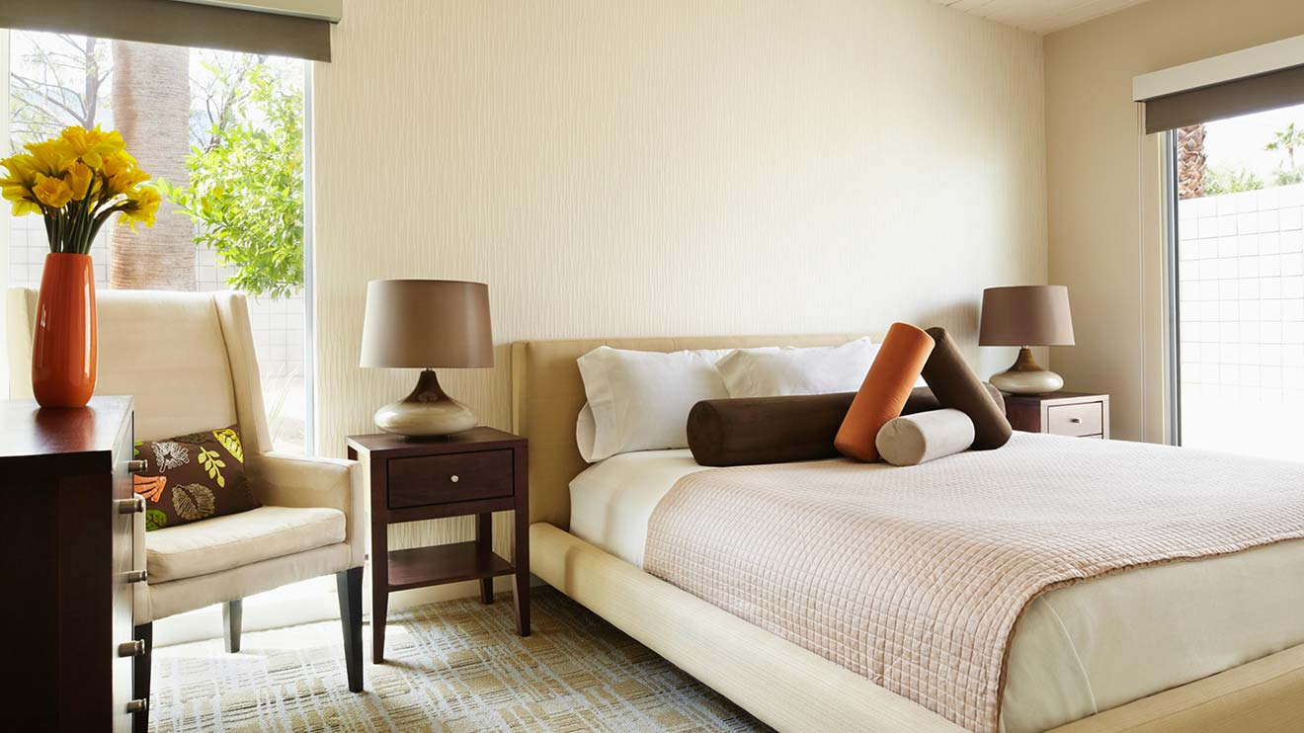

2. Hostel

Hostel is inexpensive that hotel. Hostel is for backpackers and budget living place. Usually hostel will provided share bedroom to tourist and common facilities.

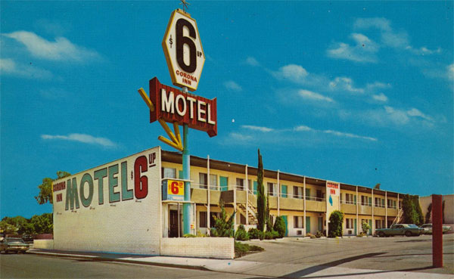

3. Boutique Hotel

Boutique hotel is decorated in themed or individual style. Boutique hotels are intimate in size and focus on providing guests with high-quality, personalized experiences. Boutique hotels will be more focus ultra-personalized service and accommodation.

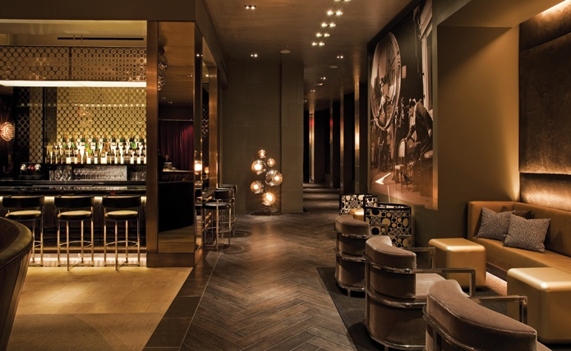

4. Resort

Resort is to give tourist feel relaxation and entertainment during vacation. The term is also used to describe a full service lodging establishment that offers extensive guest services and recreational facilities.

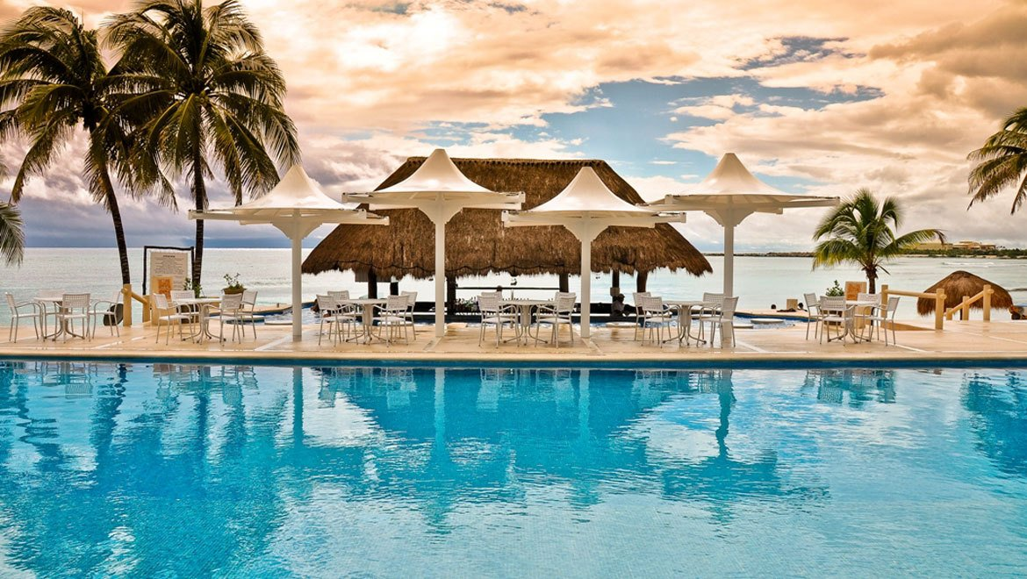

5. Eco Hotel

Eco hotel is friendly accommodation to promote natural tourism and green living through the use of renewable energy sources, recycled materials, and organic locally-sourced produce. Eco hotel will be design in a surrounding of natural environment.

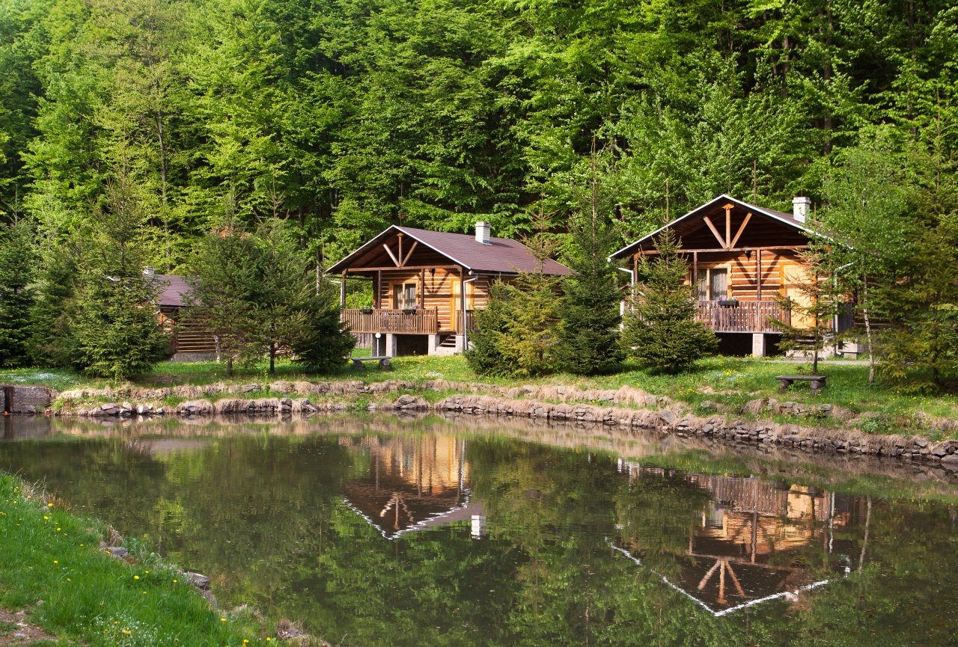

6. Capsule Hotel

Capsule hotel is a unique type of hotel that usually provides cheap, basic overnight accommodation in a number of teeny-tiny functional rooms called “capsules”. Capsule hotel also have a basic facilities but sometimes need to share their facilities during their vacation.

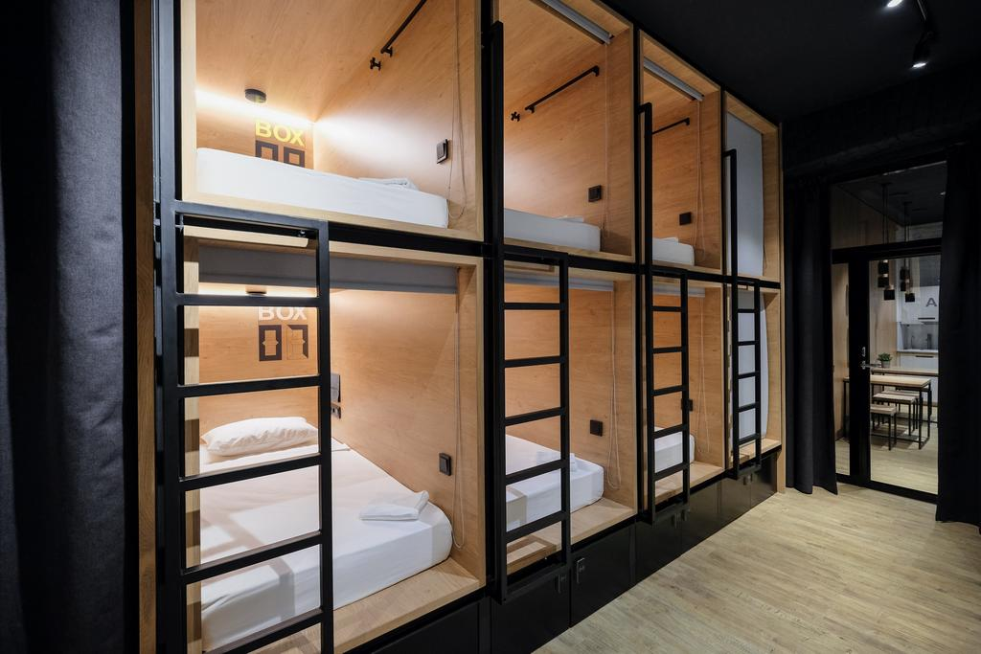

Question 4:

Explain the significant of entertainment in this industry.

Entertainment industry is a hospitality industry. Entertainment industry is related the buyers and recipients of all hospitality services. So, this sector of hospitality thrives for us and to Entertainment is a significant part of our travel these days. Tourist during traveling experience lacks fun and entertainment then you might not be able to enjoy your time up to the fullest.

Some of the activities which can elevate your experience when it comes to entertainment are:

1. Marinas

Marinas is a most popular place to come to partying and celebration. Tourist can enjoy with their friends on a private yacht where can dance, play games, and enjoy the best of your life.

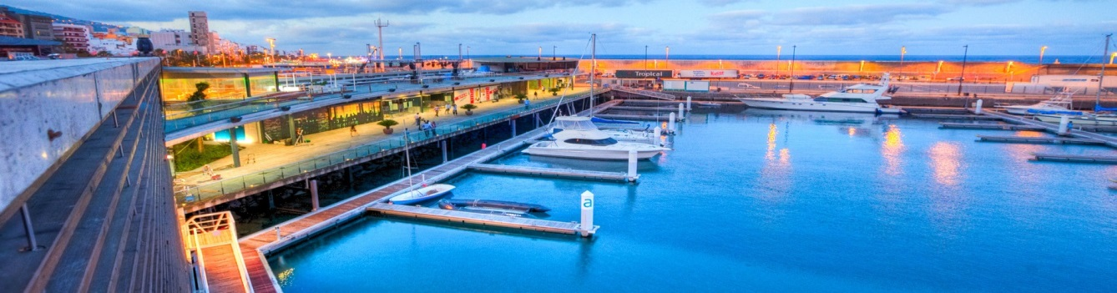

2. Sport and gamming

Sports and gaming is a basic thing which people are looking for on their travel. Casinos and swimming pools and other similar activities is a part of sector hospitality.

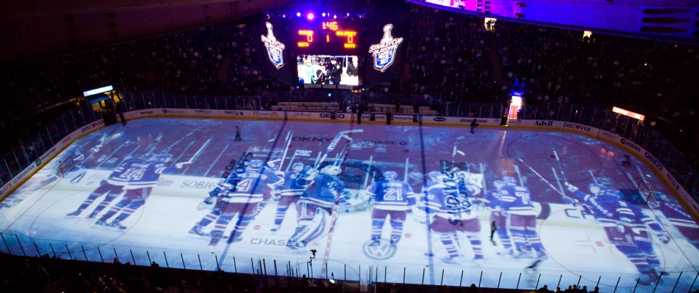

3. Cruise

Cruise also call as cruise services are also becoming an essential component of the hospitality industry. Tourist can enjoy luxury ships which sail across the blue oceans under the clear sky.

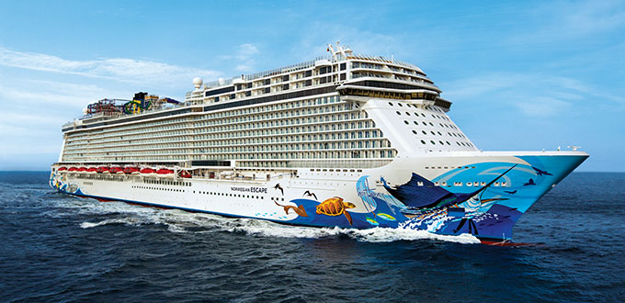

4. Nightclub

A night club that is open from the evening until early morning, having facilities such as a bar and disco or other entertainment. This is why hotels have nightclubs services in them.

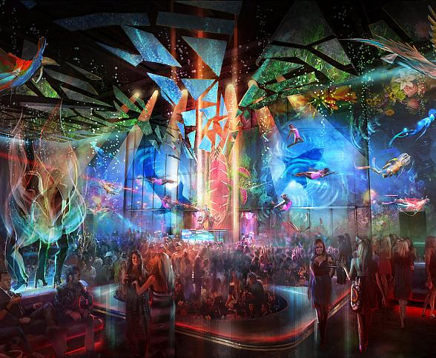

5. Bars

Sitting around a table and having a couple of drinks with your friends is always a refreshing experience. This is why bars make an important part of the entertainment sector of the hospitality industry.

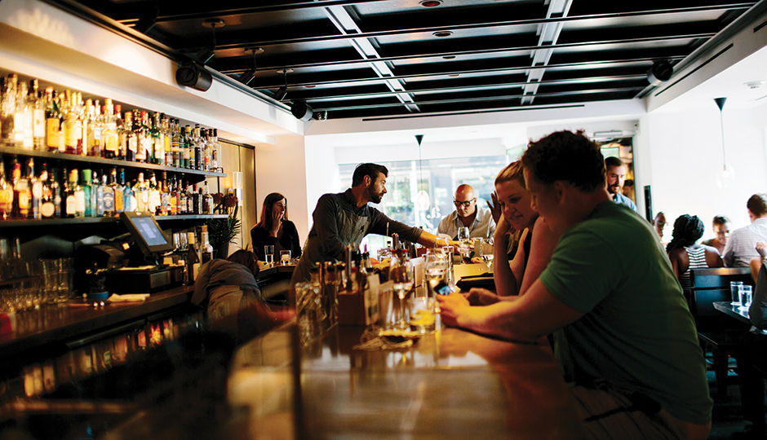

Conclusion

In this assignment, i learn about tourism and hospitality is important for tourist and services sector. Tourism and hospitality is largest services sector like food and beverage services or hotel reception service. The basis of a strong and loyal customer base that is satisfied and happy with the services from hospitality and tourism.

Hospitality and tourism can provide proper and systematic training to the staff members right from the front desk employees to the sales force the hospitality workplace. Executives are also required to be trained on a different front to acquire some special skills required to be successful in hospitality workplace which is characterized with high attrition rate and low job satisfaction among employees.

However, there is a need to install suitable equipment as per the designed training program so as to make the whole system affordable even for a small scale service oriented company.

Reference

1. The Paris pass. 2017

<https://www.parispass.com/paris-attractions/paris-attractions-guide.html>

2. China national tourism administration, 2017

<http://en.cnta.gov.cn/Festival/FestivalNews/201607/t20160719_778112.shtml>

3. Fuse Cambridge, 2017, Cambridge

<http://www.fusecambridge.com/amenities>

4. Hillary Jenkins, Sales Marketing, Feb 23, 2009

<https://www.slideshare.net/hillarypjenkins/tourism-destination-marketing1>

5. Hotels.com, 2017

<https://sg.hotels.com/ho119566/bellagio-las-vegas-united-states-of-america>

6. Pinterest (accommodation), 2017

<https://www.pinterest.com/pin/244179611024709841/?lp=true>

7. Scandic, 2017

<https://www.scandichotels.com/restaurants-bars>

8. Times out, 2017, Los Angeles

<https://www.timeout.com/los-angeles/bars>

9. Carly Ledbetter, 6 Essential Reasons To Book A Trip With A Travel Agent, Jan 17, 2015

<http://www.huffingtonpost.com/2015/01/13/why-use-travel-agents_n_6416486.html>

10. Tour Operator v3.6 – WP theme with Reservation System, 2015

<http://gfxzone.net/wordpress/tour-operator-v3-6-wp-theme-reservation-system.html>

11. What to do with a degree in Hospitality, Leisure, Retail and Tourism, Bangalore

<http://www.inurture.co.in/what-to-do-with-a-degree-in-hospitality-leisure-retail-and-tourism/>

12. Lynn, Luoping sees 14th int'l Cauliflower Culture Tourism Festival, Published: 2012-January-17

<http://en.kunming.cn/index/content/2012-01/17/content_2812519.htm>

13. Sylvia Smith, Saudi Arabia hopes for religious tourism boost, 25 May 2016

<http://www.bbc.com/news/world-middle-east-36250851>

14. Fiona Flores Watson, Travel & Tourism - Family things to do

<http://www.andalucia.com/tourism/family.htm>

15. Kerala Health Tourism, 2016

<http://www.keralatravels.com/pages/kerala-health-tourism>

16. Luana Nanu, Sports Tourism – A giant of the Tourism Market, February 7, 2017

<http://blog.hotech.com.tr/sports-tourism/>

`17. Flickr, 2017

<https://www.flickr.com/photos/malaysiatravel/sets/72157625229315399/>

18. Daisy Modiano, Greece: online reputation management & destination marketing, August 1, 2012

<https://aboutourism.wordpress.com/tag/business-tourism/>

19. Payal Chakravathy, What are the ancillary services in travel and tourism? How are they provided? , May 25,2016

<https://www.quora.com/What-are-the-ancillary-services-in-travel-and-tourism-How-are-they-provided>

20. Vinnie Jauhari, Worldwide Hospitality and Tourism ThemesISSN: 1755-4217, 2009

<http://www.emeraldinsight.com/doi/abs/10.1108/17554210910949904>

The end